Supplementary Information

Biocide identities
AgNO3: silver nitrate, BZK: benzalkonium, CTAB: cetyltrimethylammonium bromide, CHL: chlorhexidine, TRC: triclosan, CRL: chloroxylenol, PVPi: polyvidone iodine, HClO: sodium hypochlorite, GLU: glutaraldehyde, EtOH: ethanol

Supplementary Statistics
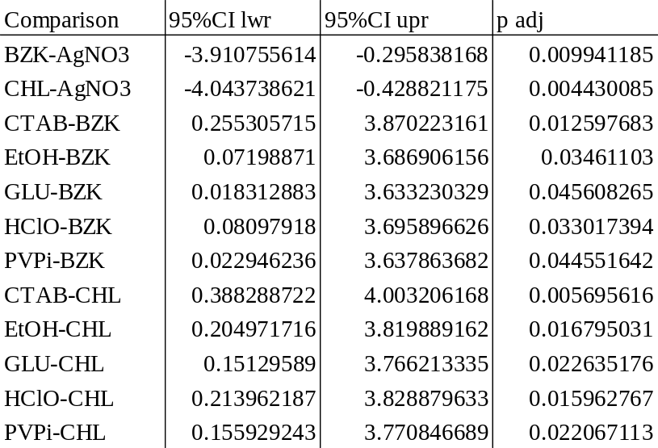
Table S0. Tukey’s HSD (95%CI, p adj) results of statistically significant differences in logFC between biocides.

Supplementary Figures
Figure S1. Skree plot of Transporter data following principal components analysis. As the curve flattens between the fourth and fifth datapoint, 4 components were considered for the subsequent factor analysis.
Figure S2. Residuals vs Fitted plot for the ANOVA assumptions testing of the logFC against gene family model. The negative slope and unbalanced spread of residuals indicates inhomogeneous variance, and thus a failure of ANOVA assumptions.

Figure S3. Q-Q plot for the ANOVA assumptions testing of the logFC against gene family model. The lack of linearity indicates non-normal residuals, and thus a failure of ANOVA assumptions.

Figure S4 Residuals vs Fitted plot for the ANOVA assumptions testing of the logFC against gene biocides model. The negative slope and unbalanced spread of residuals indicates inhomogeneous variance, and thus a failure of ANOVA assumptions

Figure S5. Q-Q plot for the ANOVA assumptions testing of the logFC against biocides model. The lack of linearity indicates non-normal residuals, and thus a failure of ANOVA assumptions.
Figure S6 Residuals vs Fitted plot for the ANOVA assumptions testing of the logFC against the interaction of gene families and biocides. The unbalanced spread of residuals indicates inhomogeneous variance, and thus a failure of ANOVA assumptions.
Figure S7. Q-Q plot for the ANOVA assumptions testing of the logFC against interaction of gene families and biocides. The lack of linearity indicates non-normal residuals, and thus a failure of ANOVA assumptions.
Figure S8 Residuals vs Fitted plot for the ANOVA assumptions testing of the logFC against the interaction of gene groups (including the hypothetical and ABC-associated proteins) and biocides. The unbalanced spread of residuals indicates inhomogeneous variance, and thus a failure of ANOVA assumptions.

Figure S9. Q-Q plot for the ANOVA assumptions testing of the logFC against interaction of gene groups (including the hypothetical and ABC-associated proteins) and biocides. The lack of linearity indicates non-normal residuals, and thus a failure of ANOVA assumptions.

